ALGORITHM FOR TWO ROBOTS
Step 1: Begin
Step 2: Input radii of robots, R₁, R₂ , source and target points of robot-1, S₁(x_{S1},y_{S1}), T₁(x_{T1},y_{T1}) and source and target points for robot-2, S₂(x_{S2},y_{S2}), T₂(x_{T2},y_{T2}) . Input velocity. Input Safety distance, S-dist.
Step 3: dist1 = 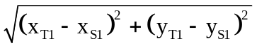
dist2 = 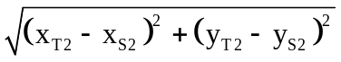
z₁ = dist1/ velocity
z₂ = dist2/velocity
r₁ = velocity
r₂ = R₁ + R₂ + safe-dist
z_{s1} = 0
z_{s2} = 0
Step 4: Total time, t = max(z₁, z₂)
Step 5: Initialize n to 0
Step 6: x₁(n) = x_{S1}, y₁(n) = y_{S1}
Step 7: Increment n
Step 8 : Find center of circle-2 as x₂(n), y₂(n) by
x₂(n) =(x_{S2} + (λ * x_{T2} )) / ( 1 + λ)
y₂(n) =(y_{S2} + (λ * y_{T2} )) / ( 1 + λ)
where λ = -(z_{S2} - n) / (z₂ - n)
Step 9 Find minimum distant point M(x_{M},y_{M}) for robot-1 by
x_{M} =(x_{S1} + (λ * x_{T1} )) / ( 1 + λ)
y_{M} =(y_{S1} + (λ * y_{T1} )) / ( 1 + λ)
where λ = -(z_{S1} - n) / (z₁ - n)
Step 10: Find centre distance C-dist between centres of C₁ and C₂
C-dist = 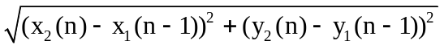
Step 11: Find the distance between Centre of C₂ and M ,
M-dist = 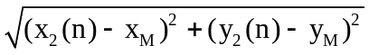
Step 12: If C-dist < (r₁ + r₂) , then C₁ and C₂ intersect , Go to 14
Step 13: x₁(n) = x_{M}, y₁(n) = y_{M} Go to 22
Step 14: If M-dist < r₂ , then M is within C₂ , Go to 16
Step 15: x₁(n) = x_{M}, y₁(n) = y_{M}, Go to 22
Step 16: x₁ = x₁(n–1), y₁ = y₁(n–1), x₂ = x₂(n), y₂ = y₂(n)

Find one of the intersection point I(x_{I},y_{I}) by
x_{I} =
y_{I} =
where, d = 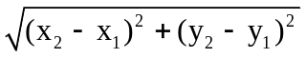
Step 17: x₁(n) = x_{I}, y₁(n) = y_{I}
Step 18: Calculate new distance, N-dist = 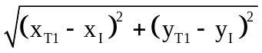
Step 19: t_{nt} = n + N-dist/velocity
Step 20 : If t_{nt} < t , Go to 22.
Step 21 : t = t_{nt}
Step 22: Record points (x₁(n), y₁(n)) for robot-1 and (x₂(n), y₂(n)) for robot-2 for solution path
Step 23 : If n < t Go to 7
Step 24: Exit

Start
Input: R₁,R₂,S₁,T₁,S₂,T₂, velocity, safe-dist
dist1 =
dist2 =
z₁ = dist1/velocity, z₂=dist2/velocity
time, t = max(z₁,z₂), n = 0
r₁ = velocity, r2 = R₁+R₂ + safe-dist
z_{S1} = 0, z_{S2} = 0

Center of circle-1, x₁(n) = x_{S1}, y₁(n) = y_{S1}

n = n + 1

λ = –(z_{S2} – n)/(z₂ – n)
x₂(n) = (x_{S2} + (λ *x_{T2}))/(1 + λ)
y₂(n) = (y_{S2} +(λ *y_{T2}))/(1 + λ)

C-dist =
M-dist =

λ = –(z_{S1} – n)/(z₁ – n)
x_{M} = (x_{S1} + (λ *x_{T1}))/(1 + λ)
y_{M} = (y_{S1} + (λ *y_{T1}))/(1 + λ)

If
C-dist < r₁ + r₂

If
M-dist < r₂

No
No
Yes
Yes
x₁(n) = x_{M}
y₁(n) = y_{M}

A
B
C

A
x₁ = x₁(n–1), y₁ = y₁(n–1)
x₂ = x₂(n), y₂ = y₂(n),
d =

x_{I} =
y_{I} =
x₁(n) = x_{I}, y₁(n) = y_{I}

N-dist =
t_{nt} = n + N-dist/velocity

If
t_{nt} < t

No
Yes
t = t_{nt}

Record points (x₁(n), y₁(n)) and (x₂(n), y₂(n)) for solution path simulation

If
n < t

No
Stop
C
Yes
B

Flowchart for collision avoidance for two robots

